**Iteration 1 Deliverables**

**Avengers Initiative**

**Alex Edelen, Megan Hanlon, Kathryn Justus, Kitrina Justus, Jimi Porter, Jake Smith**

|  |  |
| --- | --- |
| Element | Description |
| Project Sponsor | * The Office of the Executive Vice President for Research and Innovation (EVPRI) * Baylee Pulliam, Coordinator of Marketing and Communications for the Research Development and Strategic Initiatives Office at the University of Louisville |
| Business Need | * Increase Revenue for the Office of the Executive Vice President for Research and Innovation (EVPRI) and the Research Development and Strategic Initiatives Office |
| Business Requirements | * Provide effective access to internal and external grants for users of the Research Development and Strategic Initiatives website |
| Business Value | * An increase in revenue by some dollar amount |
| Special Issues or Constraints | * System specification needed before April 22, 2020 (Day of Final Presentation) * Must follow University of Louisville Branding guidelines including theme colors, logos, and definitions |

# System Request

# Narrative

Problem Statement

The Research and Innovation website is not easy to navigate for targeted audiences and lacking in a sleek and modern design, which is causing opportunities for additional funding to be lost. If it were easier to navigate, there would be more funding opportunities for the department, raising their revenue. The expected solution for the update of the website would be to make it easy to navigate a website for audiences with a sleek design that attracts users.

Business Case

The website as is does not effectively function for any of the targeted users. Keeping the website as is would allow for a decline in areas such as attraction, usability, and revenue. Making changes to the site would allow for improvement, allowing for these factors to increase, and most importantly in raising revenue.

Feasibility Considerations

We intend to deliver this project through an elaborate presentation to our client Bailey. By implementing our plan, the university will be cutting costs and bringing in more revenue due to a better web page. Our business structure is a team of six individuals with the goal of making the web page run and look as clean as possible.

# Process Models

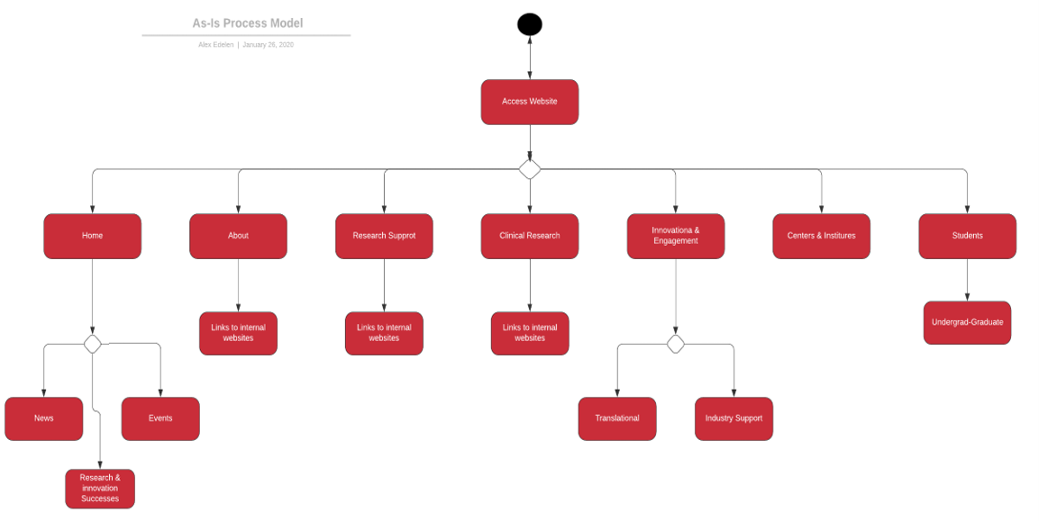As Is

The current page for the research and innovation does not have a streamlined design for a strong user experience.  The current page has many tabs that direct users to different pages. These tabs include home, about, research support, clinical research, innovation and engagement, centers and institutes, and students.

To Be

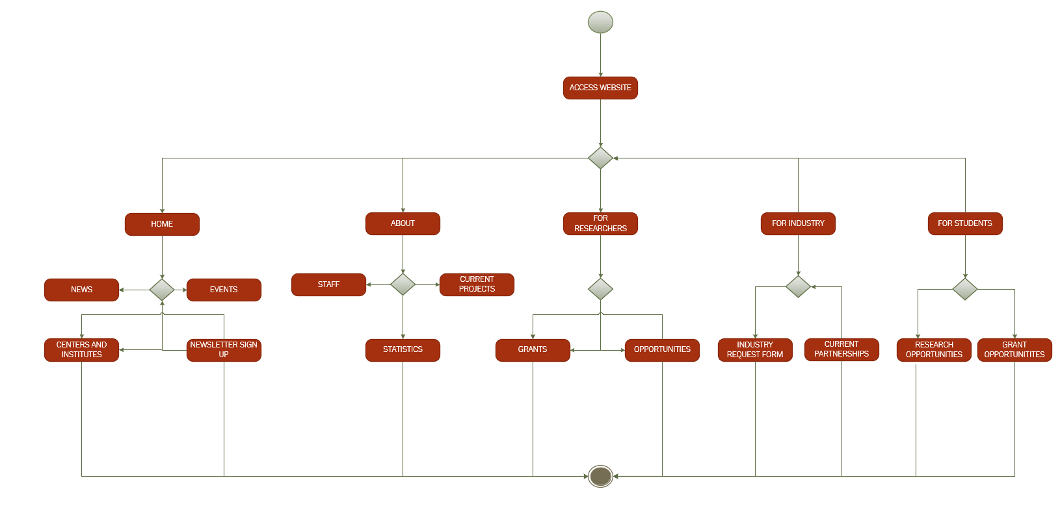

The To-Be process model is based on other, more successful research websites from peer colleges. It is very similar to the As-Is model, just reorganized. These new tabs are more directed to the audiences, allowing users to reach needed information faster.

# Vision Document

1. Introduction

The purpose of this document is to collect, analyze, and define high level needs and features of the Research and Development website. It focuses on the capabilities needed by the stakeholders and target users, and why these needs exist. The details of how the Research and development website will fulfill these needs are detailed in the use case and supplementary specifications.

****1.1 References****

Assignment #2 – 01/23/2020 – Das, Ankush "Open Source CMS : 12 Great Website Creation Tools" itsfoss 9 Nov 2019 <https://itsfoss.com/open-source-cms/> 21 Jan 2020

2. Positioning

**2.1 Problem Statement**

|  |  |
| --- | --- |
| **The problem of** | the Research and Innovation website is that the features of the website do not effectively serve their purpose in catering to targeted audiences which |
| **affects** | The general purpose of the website in providing a service to its users and allowing them to interact with the site in a way that helps them. |
| **the impact of which is** | That due to the poor performances of the features on the site, it is difficult for users to interact as well as limiting the amount of revenue collected from website activities. |
| **a successful solution would be** | Be to revise and update the features on the site to function with ease and efficiency. |

* 1. **Product Position Statement**

This product will be perfect for the Research and Innovation website because of the usability and neatness of the layout. It will be easy and cheap to set up and will work well for this project. 

|  |  |
| --- | --- |
| **For** | The Research and Innovation department |
| **Whose** | website is lacking in clarity, visual attraction, and ease |
| **The (product name)** | WordPress is a Content Management System tool |
| **That** | effectively allows for the department to design and revise their site style for attraction and ease due to the benefits of pre-designed styles and continuous updates and patches |
| **Unlike** | Joomla, which lacks flexibility and ease for inexperienced users |
| **Our product** | ,the WordPress CMS, is a tool that will ultimately allow for the desired goal of the website redesign to be successful |

3. Stakeholder and User Descriptions

The stakeholders of the system are the University of Louisville and the grant programs. They either receive funds or give funds to the research department. The users are the community, researchers, students, and industries. They each contribute to the system independent of the stakeholders. The key problems are usability and clarity. Documents and needed information are hard to locate due to unclear and unfinished tabs.

* 1. **Stakeholder Summary**

|  |  |  |
| --- | --- | --- |
| **Name** | **Description** | **Responsibilities** |
| **University of Louisville** | University with different audiences interested in the stake of the research department | Ensures that the department runs as needed and efficiently while producing the results expected from the university |
| **Grant Programs** | Different programs with interest in research and innovation willing to provide funds | Ensures that the research department have projects and research worthwhile of providing funding and grants for monetary access to whatever they may need |

* 1. **User Summary**

|  |  |  |  |
| --- | --- | --- | --- |
| **Name** | **Description** | **Responsibilities** | **Stakeholder** |
| **Community** | The community supports and donates allowing us to further our projects. | The community’s key responsibilities are to support and donate to the research department. | The user is represented directly. |
| **Researchers** | They are the ones conducting the research, so they need to be informed about current and upcoming projects. | The researcher's key responsibilities are applying for funds and conducting research. | The user is directly represented. |
| **Students** | Students can help with research and get credit. They can also get work experience to put on their resumes. | Student’s key responsibilities are assisting researchers and gaining work experience. | The user is directly represented. |
| **Industry** | Industries supply opportunities for research and jobs for students and staff. They can also form partnerships with the university. | Industries’ key responsibilities are providing research opportunities and partnerships to the university. | The user is directly represented. |

* 1. **User Environment**

We have six people on our team completing the task of reorganizing this website. In the user environment, there is a never a constant number of users in each category. It is hard to get a close estimate of each category, but there is over 1,000 people all in all that are impacted by the decisions we make.

The task cycle consists of the actual task, planning, and reporting. Our task cycle consists of brainstorming a change that would be a good fit for this site, planning the presentation to the client, and finally actually presenting the plan. Each task cycle should last about three weeks. One week for the task, one week for the planning, and one week for the reporting.

It would be ideal to have a mobile site in addition to a regular website.

Currently the website uses Plone 4 CMS. In our product, we want to use WordPress for usability and neatness.

The system currently in place is HubSpot which is a content management system that collects data from users, specifically industry users, that allows for easy requesting for collaboration with the Research and Innovation Office. Our application needs to integrate with HubSpot in the final product.

* 1. **Summary of Key Stakeholder or User Needs**

The key problems are the user friendliness and clarity. The reasons for these are that users are unable to find what they need due to unclear tabs. We can solve it by making tabs more specific and geared towards the individual users. The stakeholders would like a cheap solution to improve their websites so they can get more grants. By improving the website and making the tabs clear, we will improve interaction with the research department. By improving involvement, we will improve our chances of getting funding. The highest priority is organizing the website to increase revenues.

|  |  |  |  |  |  |
| --- | --- | --- | --- | --- | --- |
| **Need** | **Priority** | **Concerns** | **Current Solution** | **Proposed Solutions** | |
| **Broadcast messages/events** | 3 | The audience will miss events or announcements | A news tab at the bottom of the home page | | A new section designed for up to date news and events |
| **Clarity** | 1 | The audience won't know where to find information | It has some tabs that are explicit in who the audience should be | | A reorganization of the current information on the website |
| **Specification** | 2 | The audience will waste time digging through categories. | It has some broad tabs that include more specific categories. | | A reorganization of the current tabs to include more specific categories. |

* 1. **Alternatives and Competition**

Different products we could go with are other content management systems, like Joomla or Sitecore. We could also try to revamp the Plone website that the university currently uses. Strengths of Joomla are the same as the product we chose, customization and user friendliness. It is also open source, so it wont cost the university. Its weakness is that it isn’t as powerful, nor does it have as many addons available as WordPress. Sitecore is an example of a proprietary content management system, which is its weakness; we are looking for the cheapest option. Its strengths are its multiple features and supports, but it doesn’t outweigh the cost. It would be better to start with WordPress and buy addons than start off paying for it and not needing anything extra or starting on a different open source content management system and then needing more features.

Revamping the current website could be cheaper, but it would also be tougher. We'd have to edit the current infrastructure, where a content management system will let us start with the backbone created. It also would require an overhaul of the website, which means we'd have to edit the entire system anyway. We may as well start from scratch.

4. Product Overview

The product we plan on using is WordPress. It is a content management system that is free to use and very customizable. It interfaces well with other applications, which is helpful since we need to use HubSpot. It comes with mobile and desktop capabilities. You can also embed and upload media, which will allow us to customize the website to our needs. It also provides the infrastructure for the website, so we won’t need to start from scratch.

* 1. **Product Perspective**

This product can be standalone or added onto. The initial product, WordPress, is free, but if you'd like to do more complex tasks, like custom plugins or analytics support, they offer services for a low fee. Compared to other content management systems, WordPress is the most user friendly and customizable open source and the cheapest proprietary if you choose addons.

This would also be most effective for the user considering its customization abilities and its user friendliness. It will simplify the website and make it easier for the users to find what they’re looking for.

* 1. **Assumptions and Dependencies**

One assumption is that WordPress will provide all we need for free. We are relying on its low cost to outperform some of our other options, but if the features we need cost money, we may need to alter our plan. Another assumption is that Hubspot will work with WordPress. We need to keep the Hubspot forms on the website, so any website we create will need to be compatible with them.

5. Product Features

The client would like a more organized website. That is her main concern. She wants the tabs along the top of the page to be organized by user category (ex: “For Researchers” tab, “For Students” tab, etc.) and she wants the website to be able to interface with HubSpot, the platform used for form submission. Our highest priority is the HubSpot interface. We need to be able to have access to HubSpot before we can create an effective website for this client. HubSpot allows researchers to apply for collaboration with the department, so this is a feature the website must have.

Another feature that our client would like is separate tabs for each user group. This is more of a design feature, but important to the client, nonetheless. This is needed because the website, as is, is a little confusing. There are mismatched tabs and one would have to dig through the website to even find their user group. With this redesign, there would be less confusion for the user, which would mean less time spent on helping users with the website and more time helping users with the research, which is a priority for the department. This is our second priority.

Our last priority is usability. The client wants users to be able to easily log in and get the help they need. She wants easy accessibility to those who need it. We want our product to feature a “Help” button which answers frequently asked questions (FAQs) and gives a live chat, if possible. There is already a “Contact” feature on the website that allows for a user to send an email to the Research Development and Strategic Initiatives Service Account that is more geared toward returning users, but the “Help” button would be more geared toward those users who are unfamiliar with the site and can’t find something they are looking for.

6. Other Product Requirements

The main design constraint we need to be worried about is the required University of Louisville Branding rules. UofL has certain rules every university website needs to follow and because this is a department of the university, it is included in this category. The website needs a certain color theme, certain definitions, and a particular set of compliance rules, just to name a few of the constraints. This should be the highest priority because if this is not met, the website will not be allowed to be affiliated with the university.

Another priority is the Hubspot compatibility. We need those forms to continue to be accessible, so we need to make them usable in the new environment. The third priority should be effectiveness. Is the website reaching its goals, like increasing traffic or grants?

# Agile Stories

**TITLE** STUDENT

**AS A** STUDENT RESEARCHER

**I WANT TO** BE ABLE TO FIND FELLOWSHIPS AND OPPORTUNITIES

**SO THAT** I CAN BRING MY RESEARCH BACK TO THE UNIVERSITY FOR THE

BENEFIT OF THE COMMUNITY

**ID: AS1S**

**TITLE** INDUSTRY

**AS AN** INDUSTRIAL RESEARCHER

**I WANT TO** BE ABLE TO PARTNER WITH UOFL RESEARCH AND

INNOVATION

**SO THAT** WE CAN USE BETTER TECHNOLOGY AND IN TURN MAKE A

BETTER CONCLUSION

**ID: AS2I**

**TITLE** RESEARCHERS

**AS AN** INTERNAL RESEARCHER

**I WANT TO** FIND FUNDING, BOTH INTERNAL AND EXTERNAL

**SO THAT** I CAN MAKE A MORE ACCURATE CONCLUSION IN MY RESEARCH

**ID: AS3R**

**TITLE** COMMUNITY

**AS THE** COMMUNITY SURROUNDING UOFL RESEARCH AND INNOVATION

**I WANT TO** BE INCLUDED IN THE UPDATES AND FINDINGS OF UOFL R&I

**SO THAT** ICAN BETTER SUPPORT THE ORGANIZATION

**ID: AS4C**

# Team Charter

Our team, Team Avengers, consists of Kathryn Justus, Kitrina Justus, Jacob Smith, Megan Hanlon, Alex Edelen, and Jimi Porter. Our team of six has plenty of goals on how we wish to accomplish the tasks present along with ways of communication, meetings, decisions, and total project repository.

One of the main goals we wish to accomplish is to collaborate efficiently. Working in a group of six can be difficult sometimes, but we believe that we will be able to accomplish all that needs to be done as one. With that comes along avoiding procrastination. All students have very busy lives, but we are aiming to overcome the desire to push the work off and get it done when need be for the sake of each other and the difficulty of some of the responsibilities. Our final goal may be one of the most obvious, but the best goal there could be. It’s to succeed within the project and come out with the best website style and plan there could be. We will succeed in our efforts of presenting, writing papers, and carrying out what the client wants.

Thus far, our team has communicated via group message and it’s been running smoothly. Text messaging is one of the best ways to communicate among others quickly, being that most people are on their phones throughout the day. Questions and concerns about what needs to be done, when it needs to be done, or who’s going to do a specific task are some of the things easily talked about in our messages. When it comes to communicating to the instructor or the client, we will reach them via email. If we have any questions about the assignment for the instructor, we may be able to ask in class if we have the time, but if not, email is the most appropriate way for direct contact.

Our team meetings will be scheduled and announced also through the group text message. It’s the most convenient and quickest way to come to the decision of what time and day is best for everybody in the group. Our meetings will be held in the University’s library as that’s the best place for everyone to meet. They will typically be on Sundays because that’s one of the best days to work on schoolwork and one of the only days of the week all six of our members have a lot of time to get together. Most of us are working throughout the week and some work evenings. They will be conducted in a manner of dividing and conquering. We will prioritize what needs immediate attention and what needs the most amount of time for all of us to be together. Some of the work is able to be worked on individually and broken up, so that will come last on the agenda during our meetings. They will be documented on Google Drive where we’re all able to see everyone’s progress and we’re able to adjust or discuss as need be on how everything is going.

This is leading to how our team will build our consensus on our decisions and our repository. We will come to conclusions as one, rather than all independent so the project is done the fairest way possible and to everyone’s agreement. By doing so we will explain our rationale for our thoughts and be open minded toward each other. There will be pros and cons to many of our thoughts or ideas, so making the decision as a group is the best solution to finding the optimal way of concluding the project. Conflicts may be resolved in either the group message or our group meetings as they may arise outside of the meeting or during the meeting. Conflicts may be discussed in an adult manner as we are all adults and if conflicts continue to arise, there may need to be a conversation further with the instructor.

Our repository will be maintained in Google Drive or through the file exchange on Blackboard. These are the best ways for us to keep track of our work. Google Drive will be a way of working on things collectively and at our own pace as we’ll be able to go in and edit when time allows it. The file exchange on Blackboard will be where we can post documents that we will all be able to access but not all be able to edit. That’s used for more informational papers, rather than group work papers.

Appendix A

For this portion of Appendix A, we will cover three aspects of the Feasibility Analysis that will ultimately confirm our strategy for how well our plan could be viable for the Research and Innovation website overhaul.

Feasibility Analysis

* Technical Feasibility: To start off, the main issues with the Research and Innovation website is that:

1. The site is not easy to navigate for targeted audiences
2. The site is lacking in a sleek, cohesive, and modern design

Our team then decided that our best option for these issues was to implement WordPress, a CMS or Content Management System, that would handle the design, infrastructure, and functionality of the website.

* Operational Feasibility: With our main choice being to use WordPress as our new CMS, it’s capabilities when designing websites is a large range of different operations and functions that ensures the website runs smoothly and efficiently. With the available security measures, add-ons, and plugins, building the Research and Innovation website with the WordPress CMS allows for the flexibility and dependability needed to cater to all targeted audiences and ensure that we are able to improve our status as an Research 1 university and increase the amount of grants rewarded to the university to ensure we fulfill our goals of aiming higher in the research and innovation field.
* Economic Feasibility: So, with the new Content Management System being our main option for fixing the Research and Innovation, we must look at how much fiscal sense it makes to purchase this CMS. WordPress is the new CMS we chose, a management that will handle all the necessary functions and design of the website.
  + With the WordPress CMS, starting out with a basic format and functionality, the cost ranges from $46 to $100 per year with many WordPress plugins and addons available for free.
  + But to add more complexity if needed raises the cost especially for functions that catered to targeted audiences, so with a more flexible WordPress CMS design and exclusive addons or plugins the cost ranges from $300 to $400 per year.
  + <https://www.wpbeginner.com/beginners-guide/how-much-does-it-cost-to-build-a-wordpress-website/#customwebsite>

With these prices in mind, it will be an inexpensive option to go with WordPress for our new CMS to resolve the website issues. So, going with WordPress is the best option because the amount rewarded with grants will cover the cost of the CMS. Although the CMS used currently is Plone, a free CMS, it has to be said that if we don’t change the current CMS and expand the CMS capabilities by using a new one leads to the assumption that we will not raise grant amounts due to no change occurring meaning we will most likely deal with the same issues we are dealing with now.